# Objective

This example demonstrates how to dynamically change the BLE broadcaster payload in firmware.

|  |
| --- |
|  |

# Overview

The project instantiates a BLE GAP broadcaster that advertises manufacturer-specific data in non-connectable ADV mode. The manufacturer specific data is continuously updated in firmware to demonstrate dynamic advertisement payload update feature. The project also showcases low power mode configuration during and between consecutive BLE broadcast events. BLE interface configuration details are:

* GAP mode – Broadcaster
* Advertisement interval – 100ms
* Advertisement timeout – 1 hour. Device is configured in hibernate mode after this timeout
* Advertisement payload – Device name and dynamically changing manufacturer specific data
* Device HFCLK – 16MHz, CPU clock turned down to 3MHz while BLE interface is active (device can’t enter DeepSleep mode while BLE RF activity is in progress)

# Requirements

**Design Tool:** [PSoC Creator 3.1](http://www.cypress.com/PSoCCreator/) CP1, [CySmart 1.0](http://www.cypress.com/cysmart/)

**Programming Language:** C (GCC 4.8.4 – included with PSoC Creator)

**Associated Devices:** All PSoC 4 BLE devices

**Required Hardware:** [CY8CKIT-042-BLE Bluetooth® Low Energy (BLE) Pioneer Kit](http://www.cypress.com/cy8ckit-042-ble/)

# Hardware Setup

The BLE Pioneer Kit has all of the necessary hardware required for this example. shows the hardware setup for this example.

Figure : Kit Setup



# PSoC Creator Schematic

Figure 2. PSoC Creator Schematic



# Operation

shows the operation flow of this example.

Figure 3: Operation Flow



# Testing with CySmart PC Tool and Mobile Apps

1. Program the hex file for this design onto a BLE Pioneer Baseboard connected with PSoC 4 BLE module (red board)
2. Power the BLE Pioneer Baseboard and observe that it is broadcasting data (Green LED turned on)
3. Use a smart phone app (Bluetooth LE Scanner app on Android for example) or CySmart PC tool that can display changing advertisement payload and see the manufacturer specific data field continuously changing (See ).
4. The design will advertise for 1 hour and enter low power hibernate mode (Red LED on) after 1 hour.
5. Press SW2 on BLE Pioneer Baseboard to exit hibernate mode and restart broadcasting mode.
6. Modify the project to vary the duration at which the advertisement payload is updated by changing the value of

"LOOP_DELAY" in firmware or change the advertisement payload or interval as per your design requirement.

Figure 4: CySmart PC Tool – Dynamic Broadcaster Data

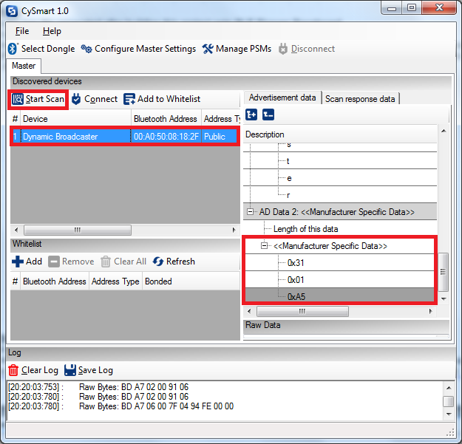

# Related Documents

lists all relevant application notes, code examples, knowledge base articles, device datasheets, and Component datasheets.

Table 1. Related Documents

| Document | Title | Comment |
| --- | --- | --- |
| [AN91267](http://www.cypress.com/go/AN91267/) | Getting Started with PSoC 4 BLE | Provides an introduction to PSoC 4 BLE device that integrates a Bluetooth Low Energy radio system along with programmable analog and digital resources. |
| [AN91445](http://www.cypress.com/go/AN91445/) | Antenna Design Guide | Provides guidelines on how to design an antenna for BLE applications. |